Your child’s cheeks, lips and/or tongue are numb and will be for up to 2 hours after leaving our office. Be careful that your child does not bite, chew, suck or scratch on his/her cheeks, lips, or tongue. Severe damage to those tissues can result from only one bite. Keep your child’s activity monitored for the remainder of the day - no high activity, please!
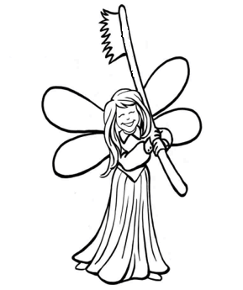
Bleeding: Your child has been instructed to bite firmly on the gauze provided to him/her for 30-45 minutes to stop the bleeding. If residual bleeding occurs, have your child bite firmly on another gauze wrap provided to you. The extraction site can slightly ooze for up to the next 24 hours. However, if the site continues to bleed, please contact our office.
Eating/Drinking: Avoid very hot or very cold fluids and foods until the freezing comes out. A soft diet is recommended for the next 24 hours. After that time, your child will tell you what he/she can eat.
Discomfort and Medication: Children typically experience very little pain or discomfort following extractions. If necessary, Children’s Tylenol or Children’s Motrin may be given as directed on the label. If antibiotics have been prescribed, take the entire prescription until finished.
Dry Sockets: If a primary tooth was extracted, we do not need to worry about dry sockets. If pain begins to diminish but elevates 3-5 days after the surgery, please contact our office.
Maintenance: Try to avoid cleaning the extraction site for the next few days. Continue to brush and floss regularly including the teeth beside the extraction site.

